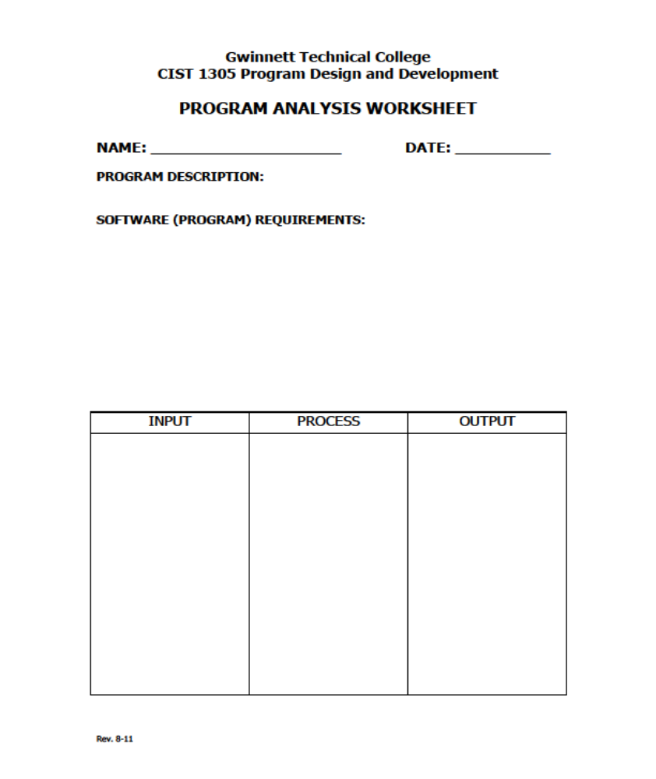
Jacob Williams

Paint Job Estimator
The number of gallons of paint required, hours of labor, cost of the paint, labor charges, cost of the paint job
NumberofRooms

priceofpaintpergallon

sqftWall

GallonsofPaint = Sqftwall / 110

Totallabor = 8 * gallonsofpaint

Costofpaint = Priceofpaintpergallon * gallonofpaint

Laborcharges = Totallabor * 25.00

Totalcost = costofpaint + laborcharges
totalCost

